Architectural Components - External API / Third-Party Services
# Source: AI Source: Provided by: [Data Path: Persons Table -> ID Column: 1, Name_En Column: Motasem Essam] -> From: [ChatGPT] on [1/23/2026]
External API / Third-Party Services are components that integrate your system with outside systems or services. They provide functionality that your software doesn’t implement itself, such as payments, notifications, analytics, or cloud services.
👉 Think of them as outsourced modules—you rely on them to do specific tasks without building everything yourself.

🔑 Key Points
# Source: AI Source: Provided by: [Data Path: Persons Table -> ID Column: 1, Name_En Column: Motasem Essam] -> From: [ChatGPT] on [1/23/2026]
- Encapsulate interaction with external systems
- Abstract external service details from your core logic
- Should handle errors, timeouts, and retries gracefully
- Keep interfaces consistent so your system doesn’t depend on service-specific details

❌ Bad Example (Direct API Calls in Business Logic)
# Source: AI Source: Provided by: [Data Path: Persons Table -> ID Column: 1, Name_En Column: Motasem Essam] -> From: [ChatGPT] on [1/23/2026]
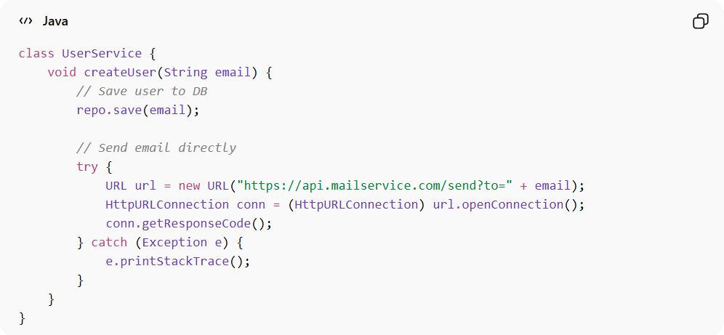
class UserService {
void createUser(String email) {
// Save user to DB
repo.save(email);

// Send email directly
try {
URL url = new URL("https://api.mailservice.com/send?to=" + email);
HttpURLConnection conn = (HttpURLConnection) url.openConnection();
conn.getResponseCode();
} catch (Exception e) {
e.printStackTrace();
}
}
}
👉 Problems:
- External API call mixed with business logic
- Hard to test UserService without actually calling API
- No abstraction or error handling strategy

✅ Good Example (Using Service Wrapper)
# Source: AI Source: Provided by: [Data Path: Persons Table -> ID Column: 1, Name_En Column: Motasem Essam] -> From: [ChatGPT] on [1/23/2026]
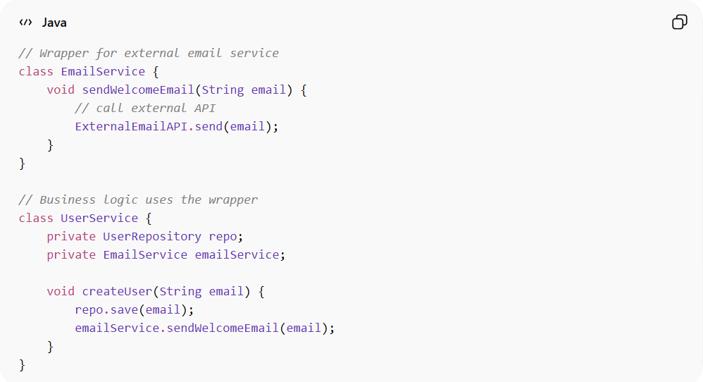
// Wrapper for external email service
class EmailService {
void sendWelcomeEmail(String email) {
// call external API
ExternalEmailAPI.send(email);
}
}

// Business logic uses the wrapper
class UserService {
private UserRepository repo;
private EmailService emailService;

void createUser(String email) {
repo.save(email);
emailService.sendWelcomeEmail(email);
}
}

✅ Benefits
# Source: AI Source: Provided by: [Data Path: Persons Table -> ID Column: 1, Name_En Column: Motasem Essam] -> From: [ChatGPT] on [1/23/2026]
- Separation of concerns: UserService focuses on business logic
- Testable: EmailService can be mocked in tests
- Error handling centralized: External failures handled in one place
- Flexible: Swap out the API service without changing business logic

💡 Summary
# Source: AI Source: Provided by: [Data Path: Persons Table -> ID Column: 1, Name_En Column: Motasem Essam] -> From: [ChatGPT] on [1/23/2026]
Treat external APIs or third-party services as pluggable components.
Keep your system isolated from their complexity and volatility.

